# Multiple Grouped Summaries

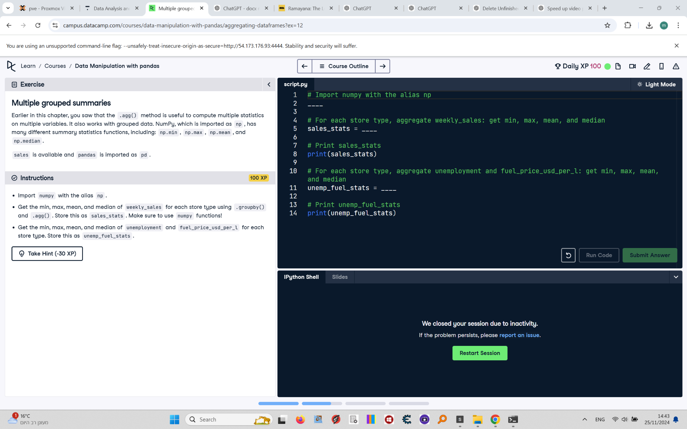

Earlier in this chapter, you saw that the .agg() method is useful to compute multiple statistics on multiple variables. It also works with grouped data. NumPy, which is imported as np, has many different summary statistics functions, including: np.min, np.max, np.mean, and np.median.  
  
sales is available and pandas is imported as pd.

## Final Answer

# Import numpy with the alias np  
import numpy as np  
  
# For each store type, aggregate weekly_sales: get min, max, mean, and median  
sales_stats = sales.groupby("type")["weekly_sales"].agg([np.min, np.max, np.mean, np.median])  
  
# Print sales_stats  
print(sales_stats)  
  
# For each store type, aggregate unemployment and fuel_price_usd_per_l: get min, max, mean, and median  
unemp_fuel_stats = sales.groupby("type")[["unemployment", "fuel_price_usd_per_l"]].agg([np.min, np.max, np.mean, np.median])  
  
# Print unemp_fuel_stats  
print(unemp_fuel_stats)